NEXT STEPS HANDBOOK
DREAM TEAM

TABLE OF CONTENTS

Welcome …………………………………………………………………………………3

Onboarding Process …………………………………………………………………….4

Organizational Chart …………………………………………………………………….6

Our Cultural Values ………………………………………………………………………7

Our Leadership Competencies ………………………………………………………….8

Expectations ……………………………………………………………………………….10

Processes, Systems, and Resources …………………………………………………...11

WELCOME

Welcome to Next Steps! Through our department, we greet, meet, and engage with guests to help them navigate the next step in their spiritual pathway. Each of us has a next step, we are continually taking next steps. Our role is to encourage conversation with other people to see where they are currently on our spiritual pathway, and how we can assist them in taking the next step that is best for them. We do this through several ways which you will learn as you acclimate to the role.

ONBOARDING PROCESS
Dream Team
- Attend Join the Team
- Express Interest in one of the teams we oversee
  - Sr. Coordinator or Coordinator reaches out to share what to expect on the team, what serving looks like, and when I will shadow first. This touchpoint is to take place within 72 hours of Join the Team completion.
  - I understand there will be an interview process for the teams of Baptism, Join the Team, and the tent team to ensure I am aligned and knowledgeable in the areas of information, and steps I am leading other people in.
- Complete background check
- Upon cleared background check, complete orientation and first shadow experience on campus.
  - In this shadow experience I am watching what the person leading me is doing. I ask questions, I observe and take notes.
  - I will be provided a Best Practices guide relative to my role. My leader will walk through this guide with me. I am responsible for knowing and internalizing the expectations outlined in the Best Practices guide.
  - The Best Practices guide and Culture guide are starting point resources for me to use.
- Complete second shadow experience on campus.
  - For the teams of Baptism and Join the Team I will have training with the Senior Coordinator or Next Steps Director in order to ensure I know and understand these processes.
  - I will shadow the experiences of Join the Team and Baptism a minimum of 3 times before I am placed as a host/facilitator of these environments.
  - During this shadow experience, I will be asked to demonstrate what I have learned thus far. This is a learning process. I am always evolving, always learning. I receive feedback and coaching openly and implement change quickly when needed.
- Once training is complete, I receive notifications allowing me to share my serving availability. I respond promptly so that my team can plan accordingly.
As I serve this house:
- I am open to feedback and coaching. I have eyes to see where areas can be improved. I give helpful suggestions and feedback.
- I respond to communication from my team and leader(s).
- I meet routinely with my leader(s) and team.
- I continually develop my skills and strive to exceed expectations. I am looking for opportunities to try new things, to stretch and grow.
o I am to continuously develop my closeness with God through quiet time, prayer and fasting.
o I am developing my gifts and talents through practice, research, reading and opportunities.
- I keep a pulse on the alignment of my gifts with my role. If I need to make a change, because God is stirring my heart, or the Holy Spirit is guiding me to take next steps, I communicate this to my leaders.

ORGANIZATIONAL CHART

The below chart outlines the Dream Teams within Next Steps Department. The Next Steps Director will develop one to one relationships with those in leadership of these teams. In a structure filled to maximum capacity you may have up to:
- 2 Senior Coordinators over Experience Teams
- 2 Senior Coordinators over Next Steps Teams
- 1 Coordinator over each team for an A and B rotation: Greeter, Usher, Parking
- 1 Coordinator over each team for an A and B rotation: Next Steps Environment, Join the Team and Baptism
- 1 Coaches over each team for an A and B rotation: Greeter, Usher, Parking, and Next Steps Environment
- 1 Coach over each team for Join the Team and Baptism. These events will likely not need more than one coach, as they do not happen each week.

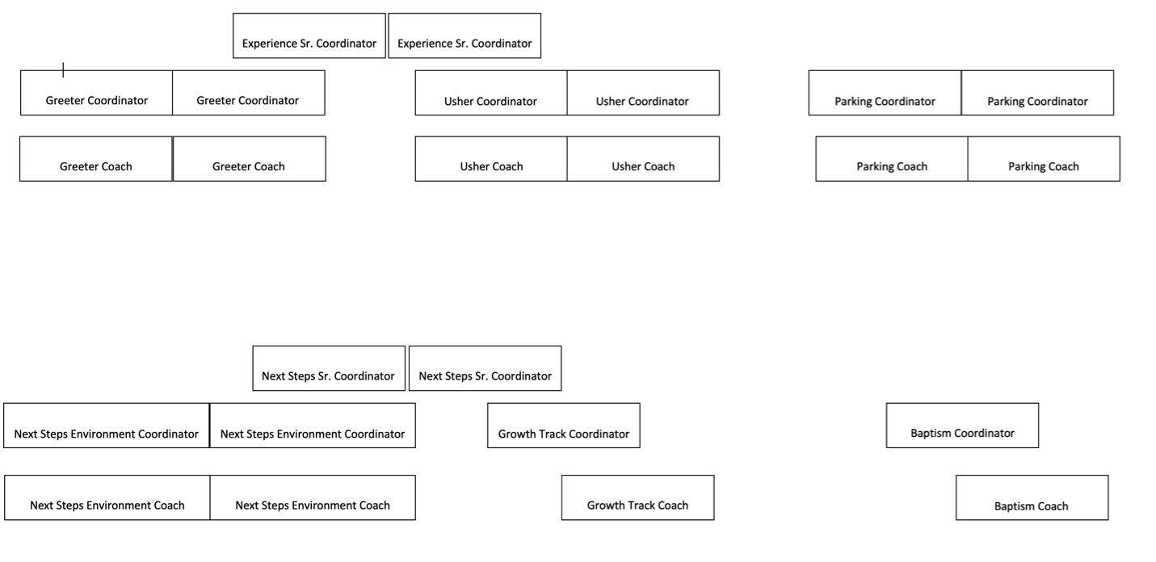

OUR CULTURAL VALUES
Our culture, our leadership, and our DNA is shaped by Jesus Himself. We look at how He invested His life, how He treated people, and how He approached His ministry. There is no better example for us to follow. Four values define our culture:

Love God
- Develop your closeness with God
- Develop your character
- Develop your calling

As a Dream Teamer you are looked to as an example of closeness with the Holy Spirit, honoring God as your closest companion. You are responsible for seeking ways of development through time with Him and growth opportunities. One great opportunity is Lifepoint College, learning and growing deeper in the Word, your faith and your knowledge. Developing and using your Spiritual Gifts is integral as part of our team.

Love People
- See people as they could be
- Say what you see in them
- Start a process to develop them

The Dream Team is known for loving people well. We do this by recognizing people as not yet friends of ours. We introduce ourselves, and engage actively. Call out what you see in others, from a great smile, to a warm spirit. Complimenting others is a great way to put them at ease and start the conversation leading them into their next step.

Pursue Excellence
- Do all things well
- Do it before you’re asked
- Do more than is expected

As a Dream Teamer I look for the unseen. Strive to ensure the environment you are in is clean, replenished and welcoming. If you have ideas to make any environment better, share them openly with your leader. Fruitful feedback makes us better together.

Be Life-Giving
- Be a servant
- Be positive
- Be enjoyable

On the Next Steps Team, we have a sweet spirit. Go out of our way to approach people at their level of comfort. Actively engage and participate in every room. Turn the dial up in the best ways. Seek out ways to give to others and serve others to show the character of Jesus through your actions. Ensure each environment is fun and honoring to the person experiencing it.

OUR LEADERSHIP COMPETENCIES

This should be an explanation of how your team/department specifically lives out the four core values of Lifepoint Church (Love God, Love People, Pursue Excellence, Be Life-Giving).

Our competencies outlined in the Staff Culture Guide are the combination of skills, behaviors, knowledge, and abilities that enable me to effectively perform my as a part of this house. Below are the core competencies along with how they apply to Next Steps specifically

Cast Vision
- Communicate the mission
- Connect people to it
- Inspire them to join

I cast vision to the Dream Team I lead, to the NSD team and to the campus staff team. In all that I do, I link people back to the mission and vision of the house through sharing with them they ‘why’ behind ‘what’ we are doing. I give them vision before making the ask, and I leak vision in all things. The ‘what’ we are doing is so much bigger than it seems. However, I know that people will not connect to what they are doing until they know the ‘why.’

For example: Instead of asking someone to pick up a wrapper off of the floor, I share how creating a distraction free, clean environment helps to break down barriers for people who are here to encounter Jesus.
Communicate Clearly, Often, and Honestly
- Create clear expectations
- Provide consistent feedback
- Tell the whole truth (give your last 5%)

Communication is vital in my role. I communicate constantly. I must be clear to those I lead what the expectations are, I must be honest yet grace-filled in feedback. While I am transparent in my communication, I am aware of my surroundings. Not everything I know is to be shared with every person I interact with. I read the room, and the situation. I am completely transparent with those who lead me, but I filter communication to Dream Team, peers, and guests as appropriate. I tell the truth always in all things.

For example: In my staff meeting we discuss how the Dream Team is creating silos by not communicating with Kidspoint team on what we are doing in the foyer. We discuss this openly, and the discussion feels tense at times. When communicating the direction we are going to the teams I oversee, I do not share the sentiments or emotions expressed in the room, instead I express the new direction we are working towards, I allow the Dream Team I oversee to be part of the solution, and I ask for their feedback. I understand that in the staff room we may disagree, but once we leave the room, we commit to the initiative(s) we have determined as a team to be a best fit for the mission we are on.

Create Opportunity
- Bring others with you
- Look for potential
- Empower people

As I learn, I share what I know with others so that they are continuously growing also. In the team I oversee, I evaluate periodically for ways they can be developed. I look for gifts and talents God has placed within them and I call out what I see that I feel God is wanting them to use, exercise or grow in. I am present with God, and allow the Holy Spirit to guide the way I lead people. I have my eyes open and my spirit alert to the people God is entrusting me with, so that I can make way for what the Spirit is doing within them.

For example: I have been asked to lead the Usher team for a night of worship. I recruit other people for this team and seek wisdom from the Dream Team who typically oversee this task on Sundays. I look to learn from others, then, I share what I have learned with others who will be on the team for the night of worship.
Cultivate an Environment of “We”
- Be loyal to the team
- Embrace collaboration
- Love sacrificially

I am committed to the mission of the Kingdom and this house. In all that I do, I think of others, those that I lead, the teams I oversee and how my efforts will impact those I do not lead, and others on my team.

For example: When I am thinking through how Ushers will support spontaneous baptisms, I collaborate with all others who are on my NSD and Campus Staff teams to drive towards what is best for this house. I also collaborate with other Dream Teams to ensure seamless, smooth transitions and an overall best experience for the guest.

Convey an Attitude of Hunger
- Always be evolving
- Pursue innovation
- Ask insatiable questions

I am always developing my closeness with God, my personal development and my ministry calling. I seek new opportunities that challenge me. I request to take the lead on projects and initiatives that will allow me to grow. In meetings of any kind, I take notes, I ask questions and I seek clarity on anything I am unclear on. I look at everything we do through the lens of how I can make it better, and how we can improve different aspects.

For example: When I am in the foyer on a Sunday and notice how guests are having to wait in line to get coffee, I think about how we can make this a better experience for them. I suggest to my leader the idea of pulling the table off the wall and creating a dual sided coffee station with double the amount of supplies. This will improve the hospitality and I trust that my ideas add value and make a difference instead of assuming we do things the way they have always been done.

EXPECTATIONS (break out by team and/or layer)

Generic & specific description of each position/layer on your team.

(this generic description will be the same for all guides and all departments)
Dream Team Member – A person who has discovered their purpose and is making a difference on the Dream Team.

- Serves in a rhythm of “serve one, attend one”. Based on the service times at your campus this could mean serving weekly or bi-weekly. Your leader will help to determine the best serving rotation for your unique role and availability.
- Regularly communicates with his or her Team Leader regarding prayer requests, personal development, and serving availability.

(this portion will vary by department/team/role)

Meetings & Rhythms (include hours expectation)
  - You will have a one-to-one meeting with your leader at your availability. This meeting is approximately one hour in length no less than once per month. This time allows you to commune with your leader and develop personally and in your role.
  - Your leader will reach out to check on you by phone, text or email. Please communicate back to your leader promptly.
  - You will have a team meeting of development/training or community nature no more than once per month and no less than once per quarter.
  - You will have a minimum of four opportunities annually to engage in training and community with other teams on campus.
  - You will have a minimum of two opportunities annually to engage in training with other teams globally.
  - All gatherings are strongly encouraged.

PROCESSES, SYSTEMS & RESOURCES

Resources List

Below are a list of the programs we use and their purpose:

Outlook – we use Outlook as our primary email for our staff and Dream Team Leadership roles. You will receive email from our lifepoint.org or lifepointvolunteer.org email addresses.

Slack – our internal communication platform. You may be invited to join slack for internal important communication for your campus.

CCB – Community Church Builder is our database system that tracks all of our systems and processes. You could also receive messages from your leader from our CCB site.

You will receive a copy of the Best Practices training document that is applicable to the team you are on! This training document will assist you in the important information specific to your serving role.

Additional Resources
- Dream Team Culture Guide https://lifepoint.org/wp-content/uploads/2023/02/Lifepoint-DTBooklet.pdf
- Dream Team Training Guides https://lifepoint.org/teamresources
- First Serve Guide https://lifepointchurch728.sharepoint.com/:w:/r/sites/NextSteps/_layouts/15/Doc.aspx?sourcedoc=%7BD8C5A2BB-3D87-4B43-9C98-D15D8262B9B3%7D&file=First%20Serve%20Best%20Practices%20Guide%2C%202018.docx&action=default&mobileredirect=true&DefaultItemOpen=1
- Experience Teams Best Practice Guide https://lifepointchurch728.sharepoint.com/:w:/r/sites/NextSteps/_layouts/15/Doc.aspx?sourcedoc=%7BCECDE293-4981-4C9B-9AA1-DC81B77CC098%7D&file=Experience%20Team%20Best%20Practice%20Guide.docx&action=default&mobileredirect=true&DefaultItemOpen=1
- Baptism Teams Best Practice Guide https://lifepointchurch728.sharepoint.com/:w:/r/sites/NextSteps/_layouts/15/Doc.aspx?sourcedoc=%7BC63AD205-BCB1-42E9-A66D-3A1D6711060A%7D&file=Water%20Baptism%20Best%20Practice%20Guide%2C%202018.docx&action=default&mobileredirect=true&DefaultItemOpen=1
- Join the Team Event Host Guide https://lifepointchurch728-my.sharepoint.com/:w:/g/personal/tzaegel_lifepoint_org/EQocnBNeBGRHkcNO6rYYXngBSMQY6V_RVhzRjF714kbaQw?e=pApiUl

THANK YOU

This guide is meant to assist in the acclimation to the role of serving on the Dream Team. You will receive hands on training, touch points, and concerted effort to walk you through each item outlined in this module. Your leader is your best physical resource for vision and direction. Also, the Director of Next Steps and Campus Pastor will be a great support as you get acquainted with the dream team, attendees and guests on the campus. You have a support system who is with you each step of the way.

You will have great success if you lean in to learning opportunities, ask questions and continuously seek wisdom from God on how to use your gifts and talents in the assignment God has placed you in serving on the Dream Team.

